IIM – SQL IM How to troubleshoot Always on Availability Group database synchronization issues

**Description :**

This document has been developed to outline the process to resolve general connectivity issues on Always on Availability group database synchronization issues.

.

**Symptoms:**

Databases not synchronizing state on the secondary nodes of the AG.

**Applicable versions:**

|  |
| --- |
| SQL Server 2012 |
| SQL Server 2014 |
| SQL Server 2016 |

**Helpdesk Instructions:**

N/A

**Service Desk** N/A

**Service ops Troubleshooting Information**

**Resolution:**

Workaround or resolution steps numbered for end users to follow (if applicable).

1. Always see default extended events related to always on are in running state. As these will be useful in troubleshooting the Always on failures

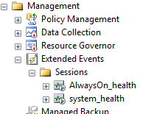

1. Check the Always on database healthy by using the below query

select db_name(database_id) as database_name, ag.name ag, ar.replica_server_name replica, ars.role_desc replicaRole, ars.operational_state_desc opState, ars.connected_state_desc connState, ars.synchronization_health_desc syncHealth, drs.synchronization_state_desc syncState, upper(ar.secondary_role_allow_connections_desc) secondaryAllowRead, ar.read_only_routing_url rorUrl

from

sys.availability_replicas ar inner join sys.dm_hadr_availability_replica_states ars on ar.replica_id=ars.replica_id inner join sys.availability_groups ag on ar.group_id=ag.group_id inner join sys.dm_hadr_database_replica_states drs on ar.replica_id=drs.replica_id

where

ars.synchronization_health_desc<>'HEALTHY' AND ( drs.synchronization_state_desc <>'SYNCHRONIZING' or drs.synchronization_state_desc <>'SYNCHRONIZED') )

OR

you can make use of the always on dash board

  Navigate to AlwaysOn High Availability->Availability Groups. Right click on Availability Groups and click on Show Dashboard.

  Once you navigate to the HADRON Dashboard, look for errors/issues on the dashboard.



.

3.  If the errors are pertaining to Network issues you will find node as down showing as RED in the availability replica as shown below and all the database will be not synchronizing on this node in AG.

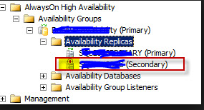

1. Open the failover cluster manager see if the node is down in the cluster in the cluster.

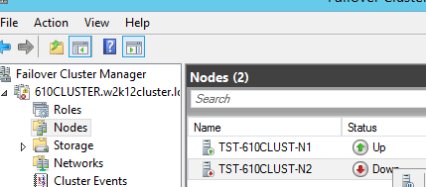

If yes on user confirmation start the cluster services on the node.

1. Check the connectivity of SQL servers from primary to secondary servers and secondary servers to primary server using the SSMS(Vice versa).
2. Check the SQL service account is having the permission on the primary and on all secondary.

If it is a permission issue you will find below logs in the SQL error logs either primary or secondary.

Database Mirroring login attempt by user 'REDMOND\xxxxx.' failed with error: 'Connection handshake failed. The login 'REDMOND\xxxxxx' does not have CONNECT permission on the endpoint. State 84.'.  [CLIENT: 10.10.10.10]

1. Check if SQL service account password is expired, you will find the logon failure for the SQL service account in the SQL error log either in primary or secondary.
2. Check if the End point on which always on is configured is enabled for connection in the local fire wall of all the nodes in AG. You can find out the end point on which always on configured. using the below query

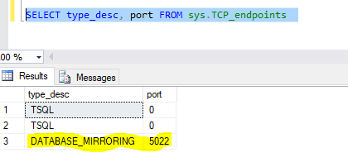

**Note: 5022 is the default port if it is not changed at the time of the configuration. If you have configured Always on more than one SQL instance on a server then you will be using the different end points ports.

1. If the node still continue to show down in the availability group talk to SMEs and get an approval to recycle SQL Services.

4. If specific database(s) in AOAG aren’t synchronizing & showing as RED / Yellow. Check whether data movement of those database(s) in the replicas is in paused state check it on both PRI / SEC. If yes you may use either of these two methods to resume the data movement.

|  |  |
| --- | --- |
| **SSMS** | **TSQL** |
|  | alter database [<database name >] set hadr resume; |

If the resume attempt fails, check the SQL error log to gather more information about the activity.

Few reasons when resume data movement may fail.

1. Due to the disk space on the secondary server (get the space cleared and resume the data movement.).
2. secondary database log cannot catch up the primary database log lsn (remove the database from AG on the secondary node and restore the log backups from the last restored lsn from the backups or remove the database from AG on the secondary and re add back)
3. when VLF count is high very high secondary database will take time to get sync with primary(if you can’t wait remove the database from AG and shrink the log and re add back)

If the issues continue even after all above check talk to SMEs.

If the above steps do not resolve the problem, please ask the user to get in touch with their BPU they may help in submitting the case with CSS if they are not able to resolve the issue at their end.

**Service Engineering-SQL Infra Troubleshooting Information :**

N/A

|  |  |  |  |  |  |
| --- | --- | --- | --- | --- | --- |
| **Revision History:** |  |  |  |  |  |
| **Date** | **Version** | **Change Descriptions** |  | **Reference Sections** | **Contributor** |
| **3/2/2017** | **1** |  | |  | **Kiran Yasa** |
|  |  |  |  |  |  |
| **Roles:** |  |  |  |  |  |
| **Owners** | **Authors** | **Contributors** | **SME** |  |  |
| **Dana Baxter** | **Murthy CS** | **MSFT's** | **Yusuf/Arun** |  |  |
|  |  |  |  |  |  |
| **Sign Off:** |  |  |  |  |  |
| **Date** | **Version** | **IIM FTE** |  | **SME** | **Supplier** |
| **9/14/2016** | **1** | **Ajitha** | **Yusuf Anis** | | **Kiran Yasa** |
| **6/23/2017** |  | **Yusif Anis** |  | |  |